Step 1: Open Windows Powershell
- Press the Win + R keys together on your keyboard to open the Run dialog box.
- Type powershell and hit Enter.

Step 2: Navigate to the Project Directory
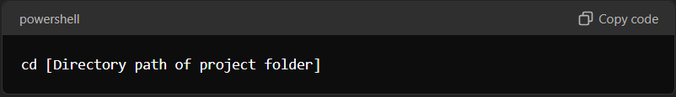
- In the PowerShell window, type the following command to change the directory to the folder containing your project documents:
Replace [Directory path of project folder] with the actual path to your project folder.

- Press Enter to execute the command.

Step 3: Install Required Libraries
- Ensure you have Python and pip installed on your system.
- In the PowerShell window, type the following command to install all the required libraries listed in the requirements.txt file:
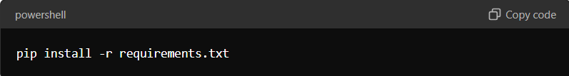
- Press Enter to execute the command.

- Wait for the installation to complete. This may take some time depending on the number and size of the libraries.

Step 4: Run the Application
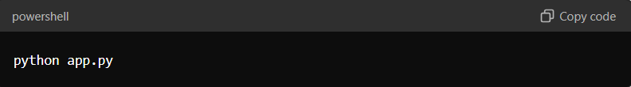
- Once the installation of the required libraries is complete, type the following command to run your application:

- Press Enter to execute the command.

Step 5: Access the Application in a Web Browser
- Open your preferred web browser.
- In the address bar, type 127.0.0.1 and press Enter.

